DAY-3 ASSIGNMENT SOLUTION

1. Write the differences between while and do while loop.?

A: The Main Difference between While Loop and Do-While is,

In While Loop the code inside the loop will be executed only if the condition specified in the while is True/Satisfied.

(or)

In While Loop, first it Checks the Condition. If it is satisfied means, then only the code inside the loop will be executed.

Whereas in Do-While Loop scenario, first it will get executed One-Time then it will check for the condition. If the condition is satisfied means, it will continue the loop execution until it is failed. Otherwise, if the condition is failed means, in this scenario we will see that the execution is done one time.

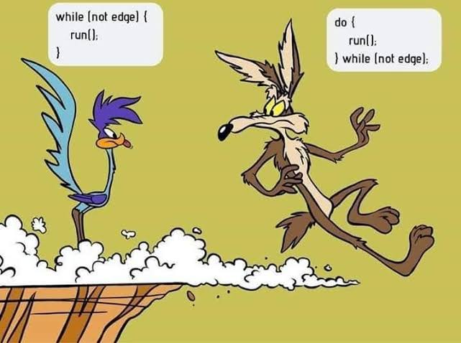

2. Write simple C# code from notepad and compile it using csc. Put the screen shot.

A: First create the <filename>.cs file 🡪 open it in Note Pad and Write the Code.

Save the file 🡪 open the path of the file in cmd prompt 🡪

Type the following Commands :

* $ csc <filename>.cs 🡪 This will compile the code, and creates the <filename>.exe file in the same location as shown in the diagram below.
* $ <filename> 🡪 Type filename without extension, this is called runtime Command. It will run our code and prints the Output.

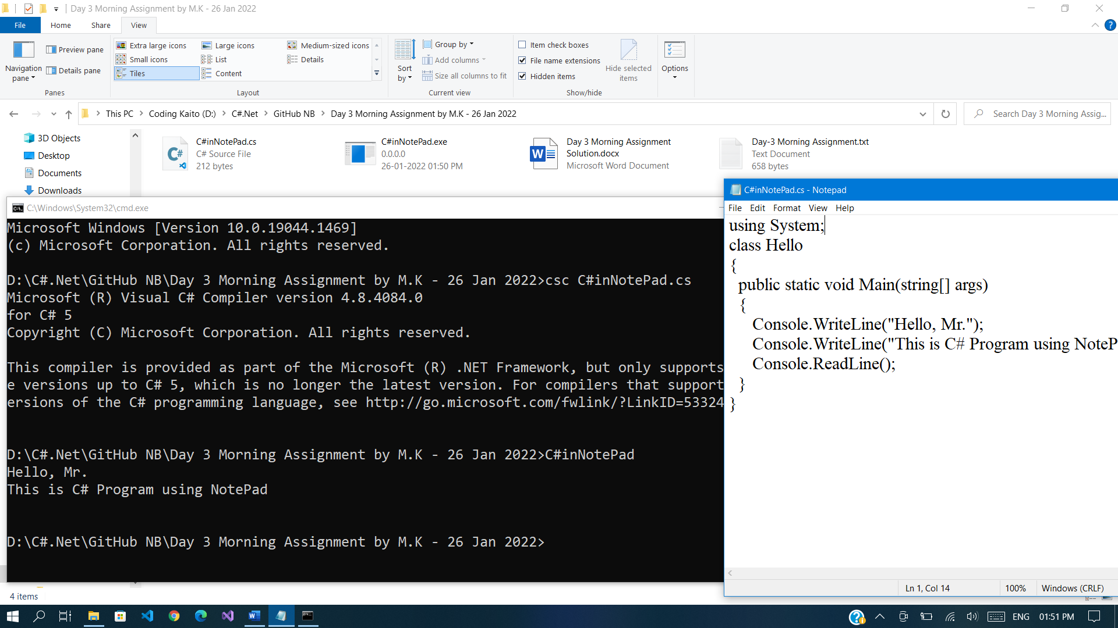

3. Create a quiz application with any five questions of your choice and ask your family members to take the quiz.

A: Check Day3Project1(Quiz Game)

4. WACP to check if entered characters are vowel or not using switch case.

A: Check Day3Project2(Vowels Checking)

5. WACP to read 5 numbers from user and print sum and average. [ using array ]

A: Check Day3Project3(Sum-Avg-using Arrays)

6. Write the 6 points about arrays discussed in the class.

A: **Arrays:**

**There are pros (√) and cons (◊) of an array with total combined into 6 points, They are:**

* Arrays are Collection of Similar data Types.
* Arrays Index starts from **Zero.**
* Arrays variable size is equal to the product of Array Length and data

type size.

**Array Variable Size = Array Length x data type size.**

* When we are initializing the array, the size is not mandatory to declare. i.e., the initialized values will itself act as the size of the array.
* Arrays require sequential memory location.
* Arrays size cannot be increased dynamically after declaration.

7. WACP to read 4 numbers from user and print the values using foreach loop.

A: Check Day3Project4(foreach)

8. WACP to initialize an array with 5 values and find sum using foreach loop.

A: Check Day3Project5(sum - foreach).